Name:

Primary School I attend:

Secondary School I will attend in September:

SECONDARY TRANSFER
You will be going to a secondary school in September and there will be things you are looking forward to and things you are a bit worried about. It will be a big change from your primary school but it is time for exciting new challenges.
Which secondary school are you going to
Do you know anyone at this school already?
What do you think the biggest change will be?

What are the two things you are most looking forward to?
1)_____________________________________________2)_____________________________________________

On a scale of 1 (not worried at all) to 10 (really worried), (circle a number how you feel about Secondary School now?)
1 2 3 4 5 6 7 8 9 10
Times and Breaks
My Secondary School is:
What time does school start:
How many breaks will there be: ……..
How long is the lunch break:.
What time does school finish:

How will I get to Secondary School?
How are you planning to travel to your secondary school?
1. If you are going to get a bus, let's think about these questions:
- Where is the bus stop and how long will it take me to get there from my house?
- What number is the bus that I will need?
- Will I need an oyster card?
- How long will the journey take?
- What if the bus is full or gets cancelled?
2. If you are going to walk, let's think about these questions:
- Do know the way?
- How long will it take me to walk to school?
e Do I know anyone else who is walking that I could walk with?
3. If you are going to get a lift in a car, let's think about these questions:
- Who will drive me?
- How long will the drive take?
- Will I get a lift back from school at the end of the day?

Equipment for School
In primary school, most of the equipment you need is kept in the classroom. But at secondary school some of the subjects that you have been learning will become a lot more specialised. There will be laboratories for science and workshops for craft design and technology. You may need to take special clothing or equipment for these subjects.
Make a list of the equipment you may need to take to school:
You will need money
It must seem an awful lot to remember but don't worry, everyone feels a bit confused at first, your time table will help you remember what you will need for each lesson.

SCHOOL RULES
Why do we have them?
Every school will have some rules for the classroom, corridors and assembly as well as rules about homework, break-times and uniform. You might not like them or even agree with them but they are there to make life safer and easier for everyone in school.
Can you think of the reasons why schools need rules?

Breaking the rules!
There will always be consequences for breaking the rules. So, it's not only important to know what the rules are but also what will happen if you don't follow them.

FINDING YOUR WAY AROUND
You might find your new school quite confusing at first. There will be lots of different buildings and more classrooms that you were used to at primary school. At the end of each period you will move to a new classroom for your next class with your next teacher. To help you find your way around, most schools have maps. Below is a sample of a school map. On the map you will see the different classrooms.
Your Tutor Group could be located in any of the above classrooms.

Music Centre |  |  | Literacy/English Rooms 1 to 12.
Maths Block |  | Assembly  Hall  Lunch Hall  GYM |  |  | Science Block
ICT
Computer
Suite

 |  |  |  |  | Art & Design Block
General Classrooms; History, Geography, Languages,

School
Reception
Main Entrance

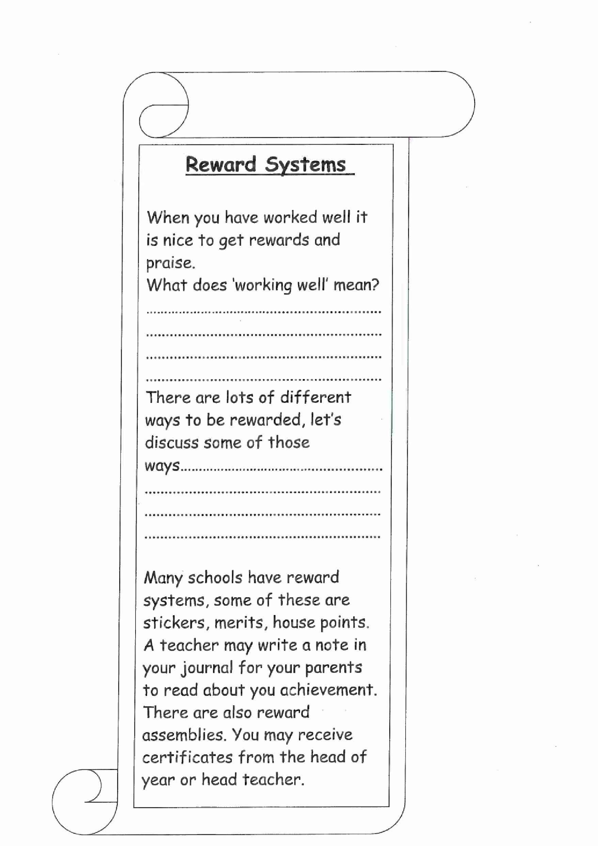
SECTION 2
Timetable
Usually one of the first pieces of information you will be given when you start your new secondary school will be a timetable. This timetable will-show you what lesson you have and what room you will have the lesson in. To follow a timetable is important in secondary school as your lessons will be in different classrooms throughout the school. You will have a journal to write this timetable in. When you have written the timetable details in make a copy. Why do you think you may need to copy the timetable?
On the timetable sometimes secondary schools will include the initials of the teachers that will take your lesson,
The day is split into periods for lessons. There are 5 or 6 periods in a day, which means there are 5 or 6 lessons in a day.
Some secondary schools work on a two-weekly timetable. This means that although most of your lessons will stay the same for both weeks some of them may change.
Timetables can be colour coded. This will help you to see very quickly which lessons you have every day and help you to know which books to pack into your bag.

Mon A Tue A Wed A Thu A Fri A
Des Tech YUT T12 | English  AJO A12 | Maths  JSM M15 | Des Tech  YUT T12 | Maths  JSM M15
Des Tech YUT T12 | Maths  JSM M15 | Drama  LWO Al | Spanish  MBV A4 | Drama  LWO Al
Tutor  CMC A3 | Tutor  CMC A3 | Tutor  CMC A3 | Tutor  CMC A3 | Tutor  CMC A3
Spanish | YUT GYM | Spanish  MBU A4 | Science  NKO 513 | ICT  LDC) T3
English  AJO Al? | RE  JPE C12 | Geography  KSM M2 | Science  NKO S13 | GAMES  YUT FIELD
Science  NKO S13 | History  TGR M12 | English  AJO Al? | Geography  KSM M2 | History  TGR M12
Maths  JSM M15 | Science  NKO S13 | RE  JPE C12 | English  AJO A12 | DesTech  STU Alb
Mon B Tue g Wed B Thu B Fri B
Art  STU A16 | English  AJO A12 | Maths  JSM M15 | Art  STU A16 | Maths  JSM M15
Art  STU A16 | Maths  JSM M15 | Music KCO A7 | Spanish  MB(-J A4 | Music  KCO A7
Tutor  CMC A3 | Tutor  CMC A3 | Tutor  CMC A3 | Tutor  CMC A3 | Tutor  CMC A3
Spanish  MBU A4 | YUT GYM | Spanish  MBU A4 | Science  NKO s13 | ICT  I-DO T3
English  AJO Al? | JPE C12 | Geography | Science  NKO 513 | YUT GYM
Science  NKO S13 | History  TGR MIZ | English  AJO A12 | Geography  KSM M2 | History  TGR M12
Maths  JSM M15 | Science  NKO s13 | JPE C12 | English  AJO A12 | Art  STU A16

AJO - Mr A Jones
CMC - Miss C McCarthy
JPE -Mr J Perkings
JSM - Ms J-A Smyth
Mrs K L Collison
NKO - Mrs N Kotz
KSM -Miss K T Smith YUT - Mrs Y UttIey-Wright
LDO -Mrs L bouto
LWO -Miss L Woodacre
MBU - Mr M Bundy
STU -Miss S Turner
TGR -Ms T Grant

TIMETABLE
Below is an example of a secondary school timetable. Look at the different subjects for each day of the week. Subjects are also known as 'lessons' and 'periods'.
Period | Mond | Tuesday | Wednesday | Thursday | Frida
1 | Registration | Assembly | Registration | Assembly | Registration
2 | English FA  M6 | Geography | Moths MS M22 | English FA | Science  JFC M4
3 | English FA | Design  Tech GIT  MIZ | Maths MS M22 | English FA  M6 | Science  JFC M4
4 | ECT CJ | Design  Tech GJT | RE PP 62 | Music HR  62 | French  ICH M33
5 | ICT GJ A9 | Design  Tech GJT  M12 | French ICM  M33 | Maths MS M22 | Geography DA A6
6 | LCT CJ | History | French ECM M33 | Maths MS M22 | Music HR  62
7 | Drama JP | PE GYM | Music HR €2 | Art GJT M12 | English
8 | Science  JFC M4 | PE GYM | PHSE | Art GCT M12 | History  DA A6
9 | Science  JFC M4 | PE GYM | PHSE FRG | Art GJT M12 | History  DA A6
- Which days do you have math's?
- Where will you be 2 ^{nd} period on Tuesday morning?
- How many periods between break and lunch?
- What books do you need to pack on Wednesday evening?
- Which day do you need your PE kit?
- How many mornings do you have assembly? Let’s colour code the timetable.

Homework
This is one of the biggest changes from your Primary School. You will be expected to do more homework than you are used to.
WHY is Homework Important?
- Sometimes homework is given to finish off work started in class.
- Sometimes homework is given to practice something you have just learnt.
- Sometimes homework is given to revise for a test.
- Sometimes homework is given to find out about something new.
- Sometimes homework is given to show the teacher if you have understood the work or not.

Consider using the Homework Club
When you start your new school, it is a good idea to go to the homework club. This is sometimes held at lunchtime and sometimes after school. It is usually held in the school library although a few schools do use the hall or a classroom.
During the homework club teachers are always there ready to help you with anything you have a problem with. They are used to helping and do not mind you asking them when you are stuck or have forgotten what you have to do.
Can you think of some reasons for using the homework club?

Homework Questionnaire
- How long will I be expected to spend on homework each night?

- How will I know what to do?

- How long will have to complete?

- What should I do if I get confused when I'm writing the homework instructions in my diary?

- What will happen if I forget to do it or forget to hand in my homework?

- What should I do if I find the homework is too difficult?

Can you think of any more questions about homework?

What if I get stuck?
Read the instructions again or ask someone else to read them to you. Have you missed something?
- Talk to your parents about what you are stuck on. Ask for their help about what to do.
- Phone a friend from school to see if they can help.
- Read something else about the subject, maybe you haven't got enough information.

When I have finished my homework
- When you have worked for long enough, check to see how you have done.
- Read through your work.
- Look for any spelling mistakes or bits that do not make sense and correct them.
- Tidy your homework away ready to take back to school to be given in to the teacher on the correct day
REMEMBER late or incomplete homework may mean a detention. However, if there is a problem please ask your parents to write a note to the teacher.

SECTION 3

LISTENING
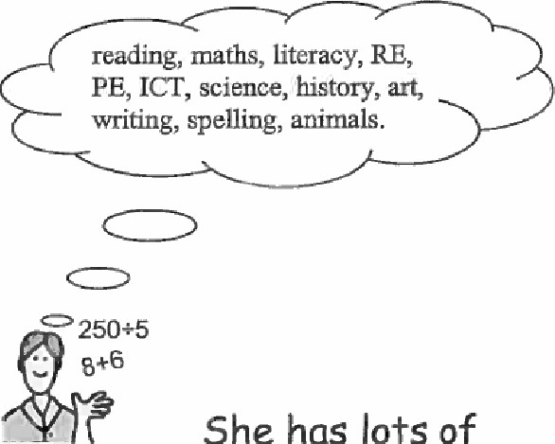
Why should I listen carefully to my teacher when she or he is talking?

My teacher knows loads of stuff. knowledge in her head.
Her job is to teach me stuff, so I will know more. This will help me as grow up.
Sometimes I might know a little bit about something and my teacher teaches me more about it.
Sometimes my teacher teaches me something new. She teaches me, then I know something about it, too. If I listen carefully, I will learn and my knowledge will grow.
Sometimes it helps me to listen carefully, if I know what the teacher is going to be teaching.
The teacher will be very pleased with me if I listen carefully and I will learn lots.
This is like giving me some of the knowledge from her head.

Reading
Reading is about the most important thing you do at school. This may be difficult if you do not like reading or find it a struggle, but it is important. List out some things you read;
Birthday Cards School Noticeboard

Reading
How good are you at remembering?
Listen to the list of words and see how many you can recall in 1 minute. You can list the words in any order.
List of words to listen to
School
Prince Charles
Hand
Pen
Homework
Spiderman
Pizza
Table
She
Under
Remember
Problem
Clock
Help
Write
Hear
See
Stand
Tall

How good are you at rememberinq?
Look at the list of 20 words and see how many you can recall in 1 minute. You can list the words in any order.

List of words to 100k at
Went
The
Book
Work And
Go Harry Potter
Of
Hamburger
Light
But
In
On
David Beckham
Note
Time
Dictionary
Paper
They

A Roman Soldier
Colour the soldier correctly, using the information on this page.
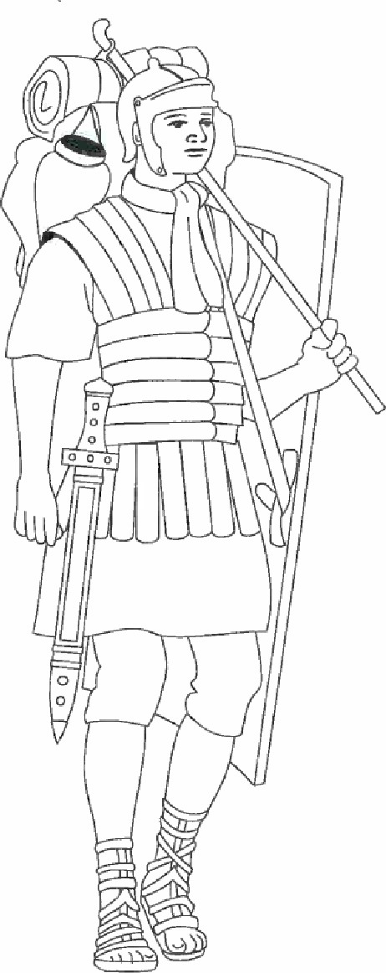
A Roman soldier wore armour and a helmet made out of metal. In the winter he would wear a tunic which was made out of wool. In the summer it would be made out of linen. These were usually red in colour.
The shield was made of plywood or leather. It curved around the body to protect the soldier. It was usually painted red, brown and beige.
Sandals were worn all the year. They were made from leather and were usually brown. The soles had iron hobnails hammered into them to make them last longer.

Highlighting
It may be useful to highlight key words when you read. Key words are the ones that are the most important ones in each sentence or paragraph. You could put these words onto a post-it sticker and then use them to revise.
Highlighting Activity: List the key words in each paragraph in the passage ^{I} A Roman Soldier'.
What is a soldier's tunic made of?

What colours were the Soldier's shield?

What were the sandals made from?

What made the sandals last longer?

SECTION 4
Making new friends
Everyone has strengths and weaknesses. Some people enjoy computers some enjoy sports, some are really good at art whilst others may find it difficult.
Some people enjoy meeting new people whilst others can find this a really difficult thing to do.
It may be up to you to start talking to other students. There are some important things that you can practice now which will make it easier. It's a bit like rehearsing for a play, it makes it easier when it's the real thing.
Circle where you think you are on the friendship scale.
No idea how to make a new friend |  | Quite confident I can make new friends |  | Looking forward to making lots of new friends
o 1 2 3 4 5 6 7 8 9 10

MAKING FRIENDS
Which of these actions suggest a person might be friendly?
Someone who smiles at me and says hello
Someone who walks away and doesn't speak to me Y/N
Someone who includes me in their conversations
Someone who makes me laugh
Someone who has similar hobbies as I do
Someone who plays the same computer games
Someone who listens to my ideas
Someone who stands with me
Someone who pushes me around in the playground
Someone who makes me feel good about myself

Here are some ideas when meeting new people.
- Smile when you say 'hello'
- Remember the other person's name
- Have something interesting to say
- Find out what their interests are
- Talk about shared interests
- Be a good listener
- Say something nice about the other person
- Perhaps ask if they want to meet at break time.
Let’s discuss some topics that we can talk to other students about. Think about the skills, talents and knowledge we already have'

WHERE TO MAKE NEW FRIENDS
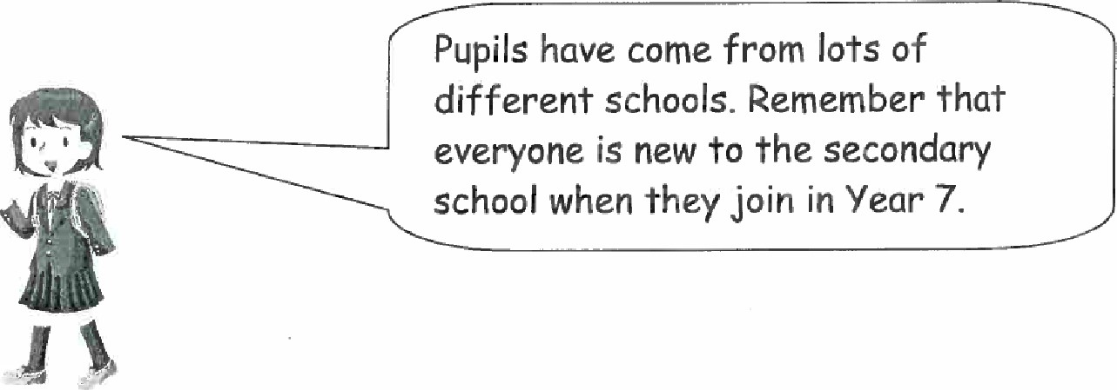
You can try to make new friends in your new class
- at a computer club
- in the playground

Who to Talk to?
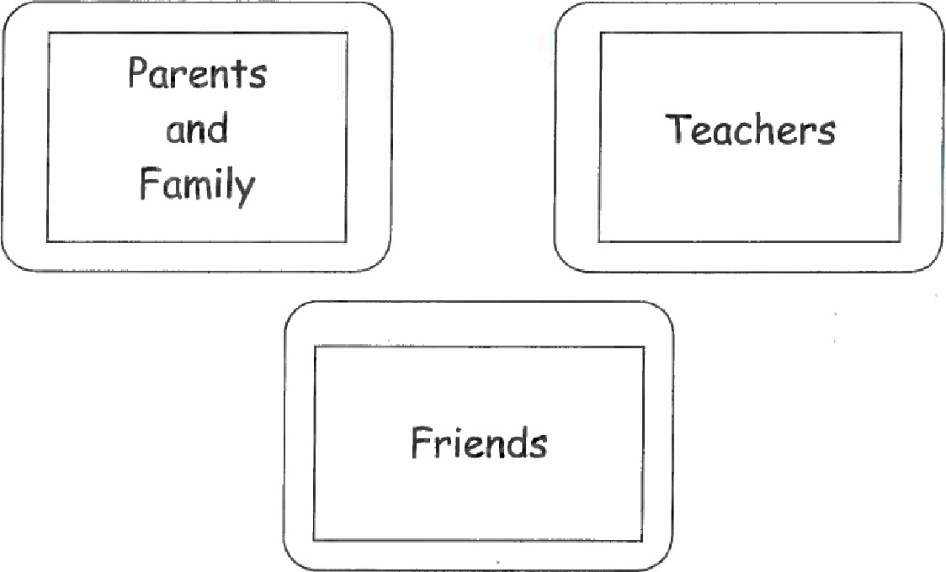
Let somebody know if you are having a problem or difficulty.
Some people find it difficult to tell an adult what is upsetting them or what is making them unhappy.
Let's think of some ways we could ask for help.
We could write a note to an adult

Section 5

Rumours
What is a rumour? Use a dictionary to find out what the word 'rumour' means, write the meaning here

Most of the children in your class might talk about going to secondary school. It's a good thing to talk about all the new exciting and challenging things ahead of you. If you have any worries or stuff that you are not sure of you could also talk to your friends about it.
Rumours are stories or reports that do not have facts to confirm their truth. Rumours usually contain lots of stuff that is not true. Parents and teachers can help you discover facts which will show you the truth.
Let's discuss an example of a rumour:
Rumour - Older students are taking mobile phones from Year 7 students.
Truth - A Year 7 student left their mobile phone in the hall; the older student found it and took it to the head of year. The head of year put it in their draw for safe keeping. The phone was eventually returned to the Year 7 student with the reminder that mobile phones are not allowed to be used on school premises.
STOP d THINK if it doesn't sound right ask an adult.

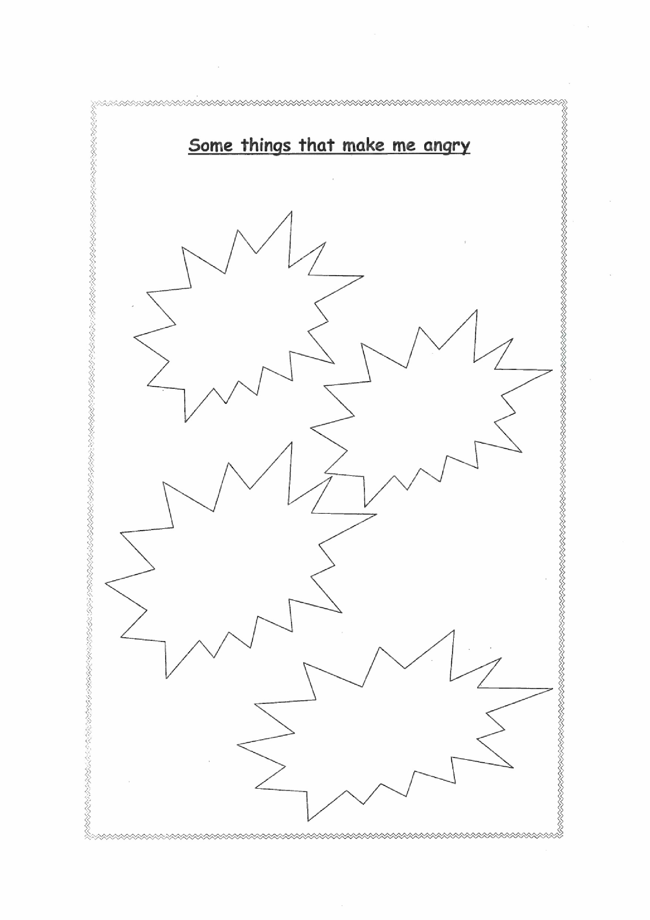

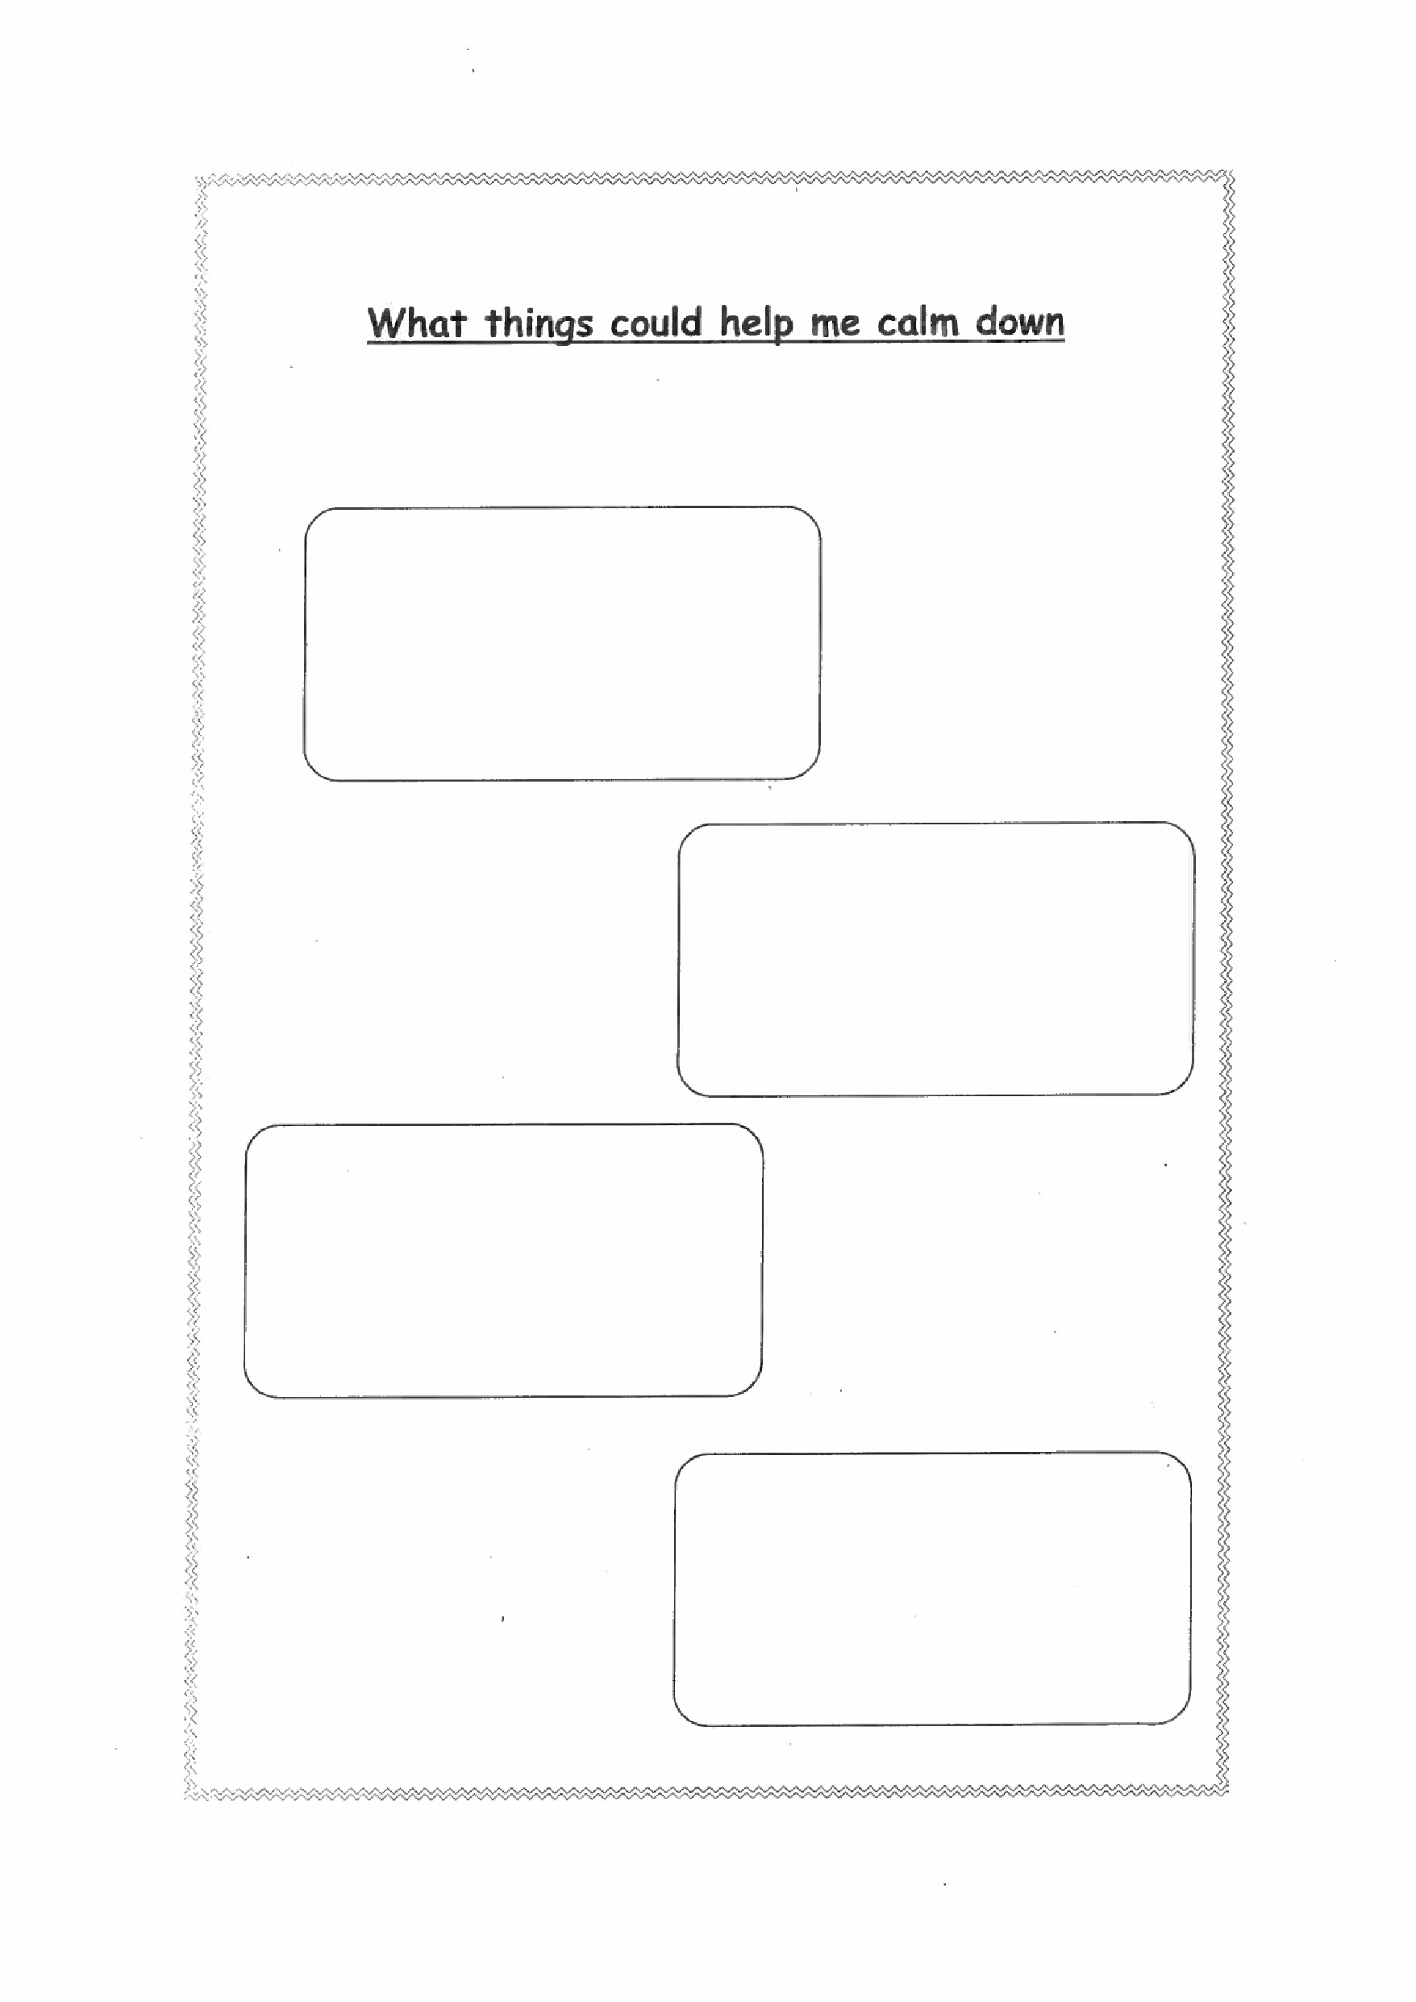

LET'S PROBLEM SOLVE
Things that might happen

For Example;
Some of the pupils make fun of you every day. They think it is funning but you do not like it.
What could you do?
It might help to practice asking for help and see if you can decide what sort of things are the best to say to explain your problem clearly, what if you
1, Lose your book
Who do you go to? What do you say?
2. Somebody bullies you in the playground Who do you go to?
What do you say?

Who to Talk to’?
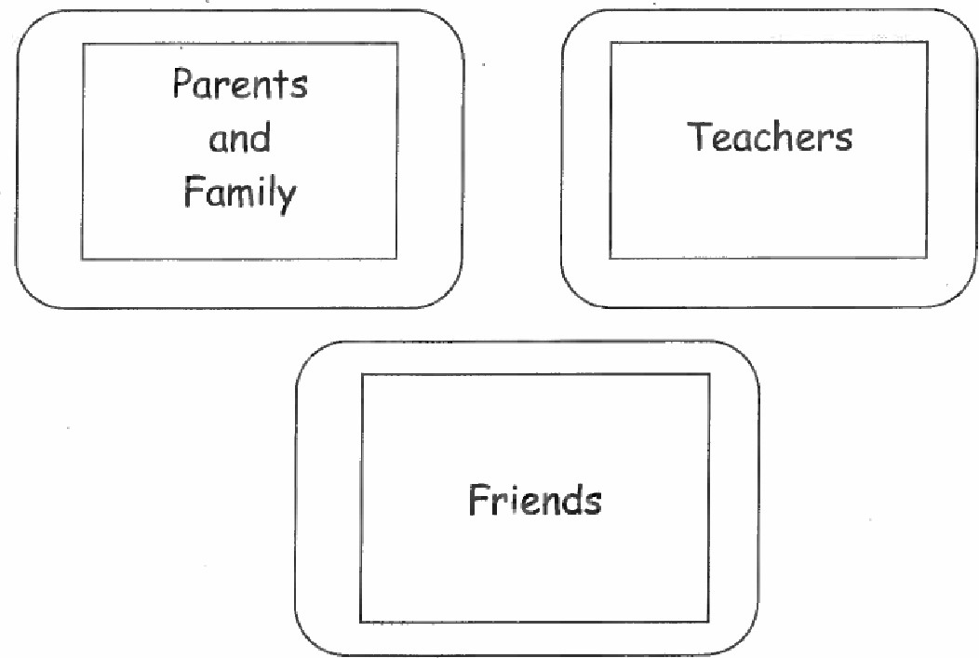
Let somebody know if you are having a problem or difficulty.
Some people find it difficult to tell an adult what is upsetting them or what is making them unhappy.
Let's think of some ways we could ask for help.
• We could write a note to an adult

On a scale of 1 (not worried at all) to 10 (really worried) (circle a number how you feel about Secondary School now?)
1 2 3 4 5 6 7 8 9 10

WORDSEARCH
 |  |  | P | c | E | O |  | R | A | p |  | Y | c | E
 |  |  |  | C |  | J |  | U |  | o | N |  | C
 |  | T | S |  | T | E |  | L | L |  |  | A |  | A
 | T | o |  |  | T | H | s | E |  | w | C | R |  | H
T | E | R | X | s |  |  | T | S |  | J | L | o
E | N |  | A | Q | H | H | o |  | E | w | o | R | K | A
N | N | R |  | A | L | L |  |  | F | K | s |  | L
s | 1 |  | V |  |  |  | Y | P | A | S |  | c
 | S |  |  | W | s | c |  | E | N | c | E | E
o |  | P | z |  | A | F |  | J | K |  |  | p | R | A
N |  | V | A | R | c |  | T | K | L | H |  | T | A | c
 | F | R | E | N | C | H |  | A | U | C | A
Z |  |  | J | H |  |  | E |  | T | s | N |  | Y | E
A |  | K | M | M | U | s | 1 | C | G | A |  | N | R
L | S | F | G | K | H |  | A |  | O |  | y | E | A

Homework | Geography | Lunch
History | French | ICT
Science | German | Rules
Art |  | Drama
 | Tutor group | Music
Maths | Reception | Tennis
Detention | Head of Year | Test
Head Teacher | Literacy | Hall
library

A-Z Game
Try to find words beginning with the following letters using school as a theme

L
M
N
O
P
Q
R
S
T
U
V
W
X
Y
Z

Acknowledgements
With thanks to Sandie Higgs for the original idea.
99} Top Tips CD-ROM - Sensei Solutions
This pack was produced by
Bexley Council
Specialist Services for Children. December 2010

