

**Support Plan:**

**Worry/ Anxiety**

[](https://www.google.co.uk/url?sa=i&rct=j&q=&esrc=s&source=imgres&cd=&cad=rja&uact=8&ved=0ahUKEwiZ3I3_58HQAhVBnxQKHQSOAP4QjRwIBw&url=https://www.youtube.com/watch?v=pDDrt6YiFNU&psig=AFQjCNHLC6I1EeO8MlKF-n01duIvIrkdWA&ust=1480091325625835)It is normal to be afraid, everyone is fearful of something. However, our worries are often for a specific reason (e.g. spiders), controllable, cause minimal physical symptoms (e.g. lip biting) and cause mild distress.

In comparison, anxiety is when your child may perceive a threat that presents no harm to them. Yet, they experience an unpleasant feeling of dread about the anticipated event which interferes with your child’s ability to function, for instance at school, can seem out of their control, may appear to be for no apparent reason but is extremely distressing for them.

The world generally can be unpredictable and very difficult to make sense of. Our minds can make up lots of different outcomes to an event which can be quite scary. Your child may find it difficult to explain why they are anxious because their imagination has created a vast range of reasons. They may be anxious about being wrong, they could become anxious because they are embarrassed easily or they may just struggle to tolerate uncertainty.

[](http://www.google.co.uk/url?sa=i&rct=j&q=&esrc=s&source=images&cd=&cad=rja&uact=8&ved=0ahUKEwjr0pStjc7QAhXD7xQKHb5UDQoQjRwIBw&url=http://www.findlayhouse.com/the-bedroom/2015/03/04/x-ray-wednesdays-marriage-and-the-freeze-fight-flight-responses&psig=AFQjCNG6HQiwU7i695_J4T9Q9Iuue6-SKg&ust=1480513614199949)Everyone has a natural survival mechanism when they are faced with a threat. This is referred to as a ‘fight, flight or freeze’ response. For example, if faced with a bully at school, some children will **fight** back; some children will **flee** (run and hide) and avoid the bully as much as possible whilst other children can become so overwhelmed with fear that they **freeze** and feel stuck. You may see similar responses in your children when they are faced with the event they are anxious about. They may fight which can present as challenging behaviours in order for you or another adult to remove them from the situation. They may flight by finding ways to distract you from taking them to the event (e.g. pretend to have stomachache). They may freeze which can present as your child disengaging and appearing like they are in their own world when faced with the event and as a result losing control over bodily functions (e.g. wetting or soiling themselves).

***Relax***

Sometimes when your child is anxious they can be overwhelmed by how their body is feeling. Anxiety can make your child experience:-

Tight muscles, headaches, difficulty sleeping, faster breathing, sweating/ hot flushes, needing the toilet (more or less frequently), loss of appetite, pins and needles, feeling light- headed/ dizzy, feeling restless, unable to concentrate and easily distracted

[](http://www.google.co.uk/url?sa=i&rct=j&q=&esrc=s&source=imgres&cd=&cad=rja&uact=8&ved=0ahUKEwi1iKSQ6MHQAhULvRQKHa7FDHEQjRwIBw&url=http://saidsupport.org/distraction-techniques-to-reduce-to-pain-and-anxiety-for-your-child-when-giving-an-injection/&psig=AFQjCNGVTIAa2HiR01IaLktus3uhZ6h8xg&ust=1480091361520364)It may be hard for your child to engage with any strategies you put in place until they start to relax. Why not try the following:-

**Breathing exercises-** Ask you child to put their hand on their tummy, take a deep breath in and then breathe out slowly like they are blowing the biggest bubble/ bubble gum ever… repeat as many times as they need

**Muscle relaxation-** Ask your child to squeeze their hands tightly into a fist like they are squeezing lemons, stand on their tiptoes and reach up to touch the ceiling, stretch like a cat and curl up like a ball as tight as they can.

**Children’s yoga/ meditation**

[](http://www.google.co.uk/url?sa=i&rct=j&q=&esrc=s&source=imgres&cd=&cad=rja&uact=8&ved=0ahUKEwjcw46V7MHQAhUGtxQKHRBVBEkQjRwIBw&url=http://wonderopolis.org/wonder/who-invented-play-dough&psig=AFQjCNGw3huw6h-I3leQbFfKhc4oNpYcjA&ust=1480092445413002)[](https://www.google.co.uk/url?sa=i&rct=j&q=&esrc=s&source=imgres&cd=&cad=rja&uact=8&ved=0ahUKEwiXiuKx6sHQAhXB1xoKHUsbA_QQjRwIBw&url=https://skinnurse.wordpress.com/2015/05/25/progressive-muscle-relaxation-script-for-parents-to-use-with-their-child-visual/&psig=AFQjCNGAxp_oChkxXF2bvLM3oUCmwtAiEQ&ust=1480091968787203)**Be active -** bounce on a trampoline, run, jump like a bunny, hop like a frog

**Sensory based activities -**  play with play dough, use a shaker (can be a toilet roll tube filled with rice and paper at the ends) or tight hugs

***Environmental change***

Is it necessary for your child to do the activity that triggers their anxiety? If a shopping trip triggers challenging behaviour can you avoid taking them?

Can they be slowly introduced to the activity? Perhaps go to the corner shop first, then a small supermarket, then larger supermarket) one day at a time.

[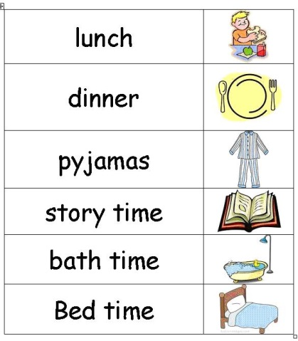](https://www.google.co.uk/url?sa=i&rct=j&q=&esrc=s&source=imgres&cd=&cad=rja&uact=8&ved=0ahUKEwjC45Wy7sHQAhXEbBoKHXU2CQYQjRwIBw&url=https://atnumber29.wordpress.com/2011/10/13/visual-timetable-graphics-download/&psig=AFQjCNFkeWCcwgwmCfKAqiUl64mklhIigQ&ust=1480093043448853)

***Thoughts***

* Talk to your child about what is worrying them. Offer suggestions to help them communicate, so you can identify specifically what is worry them
* Challenge some of these ideas but be sensitive to their perception. Often how we think affects how we will feel about a situation. So if you had to attend a business party to network by yourself…believing that you were going to fail and be unable to talk to anyone or would fall over and embarrass yourself would not help you to network well…but believing that you are going to have a good time and enjoy the possibility of meeting lots of new people would make you more successful at networking.
* Help your child to think positively about the event they are worried about in order to challenge their negative thoughts
* Use the ‘Incredible 5 point scale’ to help your child break down and communicate how they are feeling in different social situations.

The image provides an example of how it can be used. If your child is non- verbal but responds to visuals they may be able to point to how they are feeling. If your child is verbal it may provide them with phrases to appropriately communicate their thoughts and feelings. This can also help to remind your child of their strategies used to calm down when they are feeling anxious.

**[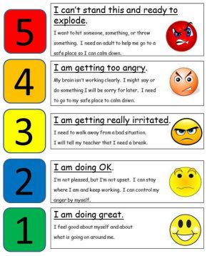](https://www.google.co.uk/url?sa=i&rct=j&q=&esrc=s&source=images&cd=&cad=rja&uact=8&ved=0ahUKEwjcmuLzhuXQAhXF7xQKHZmWDFcQjRwIBw&url=https://www.pinterest.com/explore/5-point-scale/&psig=AFQjCNFWpzEEvXUt9erbP2Q4GWhKpd1ZSQ&ust=1481302211708631)*Prepare and Support them***

* If your child worries about getting it wrong, could someone support them through the activity and explain what may be expected of them to reduce the fear or failing
* Would a timetable of what is happening next or a daily schedule help relieve your child’s uncertainty?
* [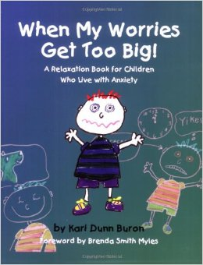](https://www.google.co.uk/url?sa=i&rct=j&q=&esrc=s&source=imgres&cd=&cad=rja&uact=8&ved=0ahUKEwjF6-zz7sHQAhVGWxQKHfM7CPEQjRwIBw&url=https://www.amazon.com/When-Worries-Relaxation-Children-Anxiety/dp/1931282927&psig=AFQjCNF0zE_x10LT3yfAMFyvp6iT_a-ggg&ust=1480093181209572)[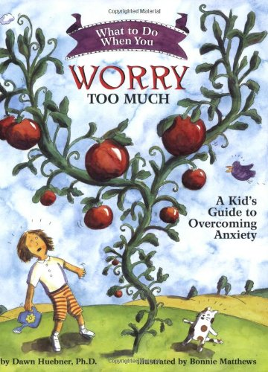](https://www.google.co.uk/url?sa=i&rct=j&q=&esrc=s&source=imgres&cd=&cad=rja&uact=8&ved=0ahUKEwjx4uX17sHQAhVBORQKHRlqCZ4QjRwIBw&url=https://www.amazon.ca/What-When-You-Worry-Much/dp/1591473144&psig=AFQjCNFIzSvmDDIGXlVdz-1zpxAMF9H0WQ&ust=1480093185218306)[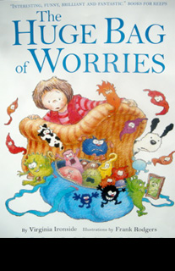](http://www.google.co.uk/url?sa=i&rct=j&q=&esrc=s&source=imgres&cd=&cad=rja&uact=8&ved=0ahUKEwi_16uB78HQAhUGvhQKHZy4DN8QjRwIBw&url=http://frankrodgers.co.uk/&psig=AFQjCNFmfnVK6XtS_dYBiXwPuyTgoDev4Q&ust=1480093170904476)Have you tried to read a story that shows children being afraid of doing the activity and then enjoying it?

If you know the reason for your child’s anxiety it may be good to write them a social story which would direct your child on what they may encounter in a specific situation, how others may react, how they may respond and what they could do to make themselves feel better.   
Refer to Carol Gray’s book ‘The new social story book’.

[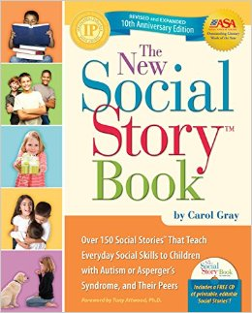](https://www.google.co.uk/url?sa=i&rct=j&q=&esrc=s&source=images&cd=&cad=rja&uact=8&ved=0ahUKEwiJ_LDDi-XQAhVFbxQKHbGyB2AQjRwIBw&url=https://www.amazon.co.uk/New-Social-Story-Book-x/dp/1935274058&psig=AFQjCNH7valAWWbt_upymeFvTwXa5oeKEw&ust=1481303412249141)

**Celebrate, reward and praise your child when they overcome the identified worry.**

**Web based self-help tools and advice:**

In conjunction with Young People we have developed a web based programme called Headscape. This has information, tips and advice and helpful things to download; here’s how to access it:

[**http://headscapebexley.co.uk**](http://headscapebexley.co.uk)

Other websites that you might find helpful are:

<http://familylives.org.uk> Previously parent line – online forums and parent courses

[www.onespace.org.uk](http://www.onespace.org.uk) Website for single parents – online forum, courses and information

[www.psg.org.uk](http://www.psg.org.uk) Parent Support Group - helpline and advice

[www.youngminds.org.uk](http://www.youngminds.org.uk) YoungMinds’ Parents’ information service

[www.royalgreenwich.gov.uk/fis](http://www.royalgreenwich.gov.uk/fis)Greenwich Families Information service

[www.dad.info](http://www.dad.info) Website has articles podcasts etc

[www.childline.org.uk](http://www.childline.org.uk) Tel: 0800 1111