For children and young people with learning disabilities, health and/ or autistic spectrum conditions coming into hospital

It needs to hang on the end of my bed and a

copy should be put in my notes.

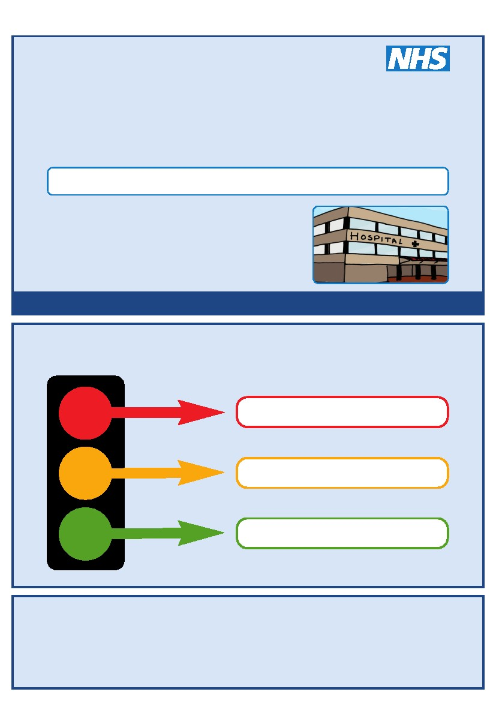

This is my

Hospital Passport

**My name is:**

If I have to go to hospital this book needs to go with me.

It gives medical staff important information about me to make sure I get the best care.

This passport belongs to me. Please return it when I am discharged.

**Hospital staff please look at this document before ANY investigation, care or treatment**

**Things you must know about me**

**Things that are important to me**

**My likes and dislikes**

|  |
| --- |
| **Things you MUST know about me** |
| C:\Users\Weste3\AppData\Local\Temp\Widgit\ca7a4cef-6f00-40e5-8ead-98e6b807df58\InPrint image.png  **I like to be known as:**  **My birthday is:**  **My NHS no is:**  **My Address:**    **My Telephone No:**  C:\Users\Weste3\AppData\Local\Temp\Widgit\a16076f9-c6b7-48c6-a5a4-aa6aeb68d3e3\InPrint image.png  **GP Name**:  **GP Address**:  **GP Phone**:  **Medical interventions (how to take my blood, Blood Pressure, give injections etc):**  C:\Users\Weste3\AppData\Local\Temp\Widgit\b5286e9b-27a2-42c8-8d84-34fa89024c70\InPrint image.png  C:\Users\Weste3\AppData\Local\Temp\Widgit\dc92a239-635b-4e81-ad9c-0814580a0451\InPrint image.png  C:\Users\Weste3\AppData\Local\Temp\Widgit\04703259-62a6-4616-a0d9-1fae1fc88d69\InPrint image.png  C:\Users\Weste3\AppData\Local\Temp\Widgit\10970b1a-04aa-46e0-9f31-010a2f94863c\InPrint image.png  **Allergies:**  **Eyesight / hearing:** |
| **Things you MUST know about me** |
| **Capacity:** This health document gives information regarding the amount of support I need to undertake my activities of daily living. However, it should NOT be seen as or used as a baseline and all people with learning disabilities should be assumed to have capacity until assessed otherwise.  **How I communicate:**  C:\Users\Weste3\AppData\Local\Temp\Widgit\1fd06698-9f88-4dec-9666-ad49ba2a26c5\InPrint image.png  C:\Users\Weste3\AppData\Local\Temp\Widgit\b7cdc593-5df3-4309-8e10-4e070388996e\InPrint image.png  **What to do when I’m anxious:**  C:\Users\Weste3\AppData\Local\Temp\Widgit\ccf06381-32a8-4ee1-beb3-bf853de8e59e\InPrint image.png  **How do you know if I am in pain?**  ***Does the patient have a DisDat (Disability Pain & Distress Ax)?***  **How I take medication:**  ***For current medication please see MAR***  C:\Users\Weste3\AppData\Local\Temp\Widgit\2f64d829-cfad-4350-8bd7-7a5315144223\InPrint image.png |
| **Things you MUST know about me** |
| **How I eat:**  **(On my own/with others, method of eating, particular foods or consistencies can/can’t eat, do/don’t like etc)**  **How I drink:**  **(Particular drinks can/can’t drink, do/don’t like, method of drinking, consistency/thickened fluids etc)**  C:\Users\Weste3\AppData\Local\Temp\Widgit\803943b4-ebc1-492a-b1c3-aeabe4f14292\InPrint image.png  C:\Users\Weste3\AppData\Local\Temp\Widgit\078b75df-7507-4066-a182-1f79e6cbbea5\InPrint image.png  **How I use the toilet:**  **(Continence aids, help to get to the toilet)**  C:\Users\Weste3\AppData\Local\Temp\Widgit\a77e3cb9-83c3-411e-914a-62b3d8c395f4\InPrint image.png**Personal Care:** C:\Users\Weste3\AppData\Local\Temp\Widgit\ef0599e4-61e2-4794-823c-bb98b501e05f\InPrint image.png  **(Dressing, washing, etc)**  **How I mobilise:**  **(Posture in bed, walking aids)**  C:\Users\Weste3\AppData\Local\Temp\Widgit\21274d3e-0bb7-48b6-b2fe-aa4b07aa0042\InPrint image.pngC:\Users\Weste3\AppData\Local\Temp\Widgit\94e9f9c2-fb1e-4b96-b6cb-518d316f936b\InPrint image.png  **Sleeping:**  **(Sleep pattern/ routine)**  C:\Users\Weste3\AppData\Local\Temp\Widgit\8055db70-5726-4b8f-8c11-04c7c67badb4\InPrint image.png |
| **My baseline and routine**  C:\Users\Weste3\AppData\Local\Temp\Widgit\27a2ab7c-0652-41fd-b527-cad635829393\InPrint image.png  **What I’m usually like…**  *(e.g. I am normally very chatty and enjoy talking to everyone, I don’t smile that often but that doesn’t mean I’m not enjoying something, I am very curious so will often ask lots of questions etc.)*  **My morning routine**  *(e.g. I am a morning person and like to be up for breakfast around 8am, I then enjoy going on walks and get quite restless if this routine is broken. Please ensure that if I have my Scooby doo slippers with me they are offered for this walk as they are my favourite slippers. I am a very active person etc.)*  C:\Users\Weste3\AppData\Local\Temp\Widgit\35e5ae1a-2a46-4a2f-a1b7-59537d2f728f\InPrint image.png  **My afternoon/evening routine**  *(e.g. after lunch I like to have a nap for roughly an hour, I will then normally chat or do some drawings for most of the afternoon – this is my chill time. After dinner I like a book read to me before bed so please if this isn’t available explain that to me as I may become distressed if I don’t understand why my routine has changed. I go to bed around 10pm etc.)*  C:\Users\Weste3\AppData\Local\Temp\Widgit\27cf2e3f-f03f-469f-b430-72953e9ca117\InPrint image.png |
| **Communication** |
| Wherever possible we will:   * Present information in a written or visual format and respect the need for you to process it without pressure. * Give clear, step by step information about what is happening, when and with whom in a written or visual format. * Give advance warning where possible of changes of plan or routine. * Keep verbal communication brief and to the point especially at times of stress. * Avoid using face to face communication unless unavoidable.   Please describe anything else which will help us communicate effectively and sensitively with you:   |  | | --- | |  | |  | |  | |  | |  | |  |   C:\Users\Weste3\AppData\Local\Temp\Widgit\7241b6cf-5230-46c0-8efc-1c9a41239c15\InPrint image.png |
| **Socialising / interacting with others** |
| Wherever possible we will:   * Use a traffic light or similar discreet system to judge whether or not you are able to engage in social interaction * Respect your preference or need for solitude and rest after social interaction * Avoid involving you in small talk unless you wish it * Avoid overloading you with a lot of ‘chat’ or ‘banter’ * Be respectful of your areas of interest and expertise   Please describe anything else which will help us create a comfortable social environment for you during your stay in hospital:   |  | | --- | |  | |  | |  | |  | |  | |  |   C:\Users\Weste3\AppData\Local\Temp\Widgit\c27d6c04-f6b5-44cc-92d8-b0c4f01e6f6d\InPrint image.png |
| **Sensory perception** |
| Are you under (hypo) or over (hyper) sensitive in one or more sensory areas?  If so please complete the box below. If possible please bring any stim items with you to hospital:   |  |  |  |  | | --- | --- | --- | --- | | **Sense** | **Over (tick)** | **Under (tick)** | **How does this affect you?** | | **Touch/ texture** |  |  |  | | **Taste** |  |  |  | | **Smell** |  |  |  | | **Visual** |  |  |  | | **Hearing** |  |  |  | | **Balance** |  |  |  | | **Spatial awareness** |  |  |  | | **Perception of heat, cold, pain, need to use the toilet, Nausea etc.** |  |  |  | |
| **Intense focus or interests** |
| Wherever possible we will:   * Support your need to engage in and discuss your intense focus or interests * Support your need to stim, to move away from or shut down/reset as a result of overstimulation * Support your need for predictability & routine and your difficulty with change, ambiguity or interuptions to these, to thought processes or conversations   Please describe anything else which will help us create a comfortable environment for you during your stay in hospital:   |  | | --- | |  | |  | |  | |  | |  | |  |   C:\Users\Weste3\AppData\Local\Temp\Widgit\07f96d7d-417b-4521-92eb-9b3e00f545e7\InPrint image.png |
| **Important Information – Family / Carers** |
| C:\Users\Weste3\AppData\Local\Temp\Widgit\43f8061d-dfe0-4772-a9f1-74c6e9cca54e\InPrint image.png  **Main carer / support:**  **Relationship to me:**  **Address:**  **Tel No:**  ***Please see Family/carer & Hospital Partnership checklist***    C:\Users\Weste3\AppData\Local\Temp\Widgit\9a6b21c5-5c51-485c-8c0d-0871a01b54ab\InPrint image.png  **Support to medical appointments:**  **Support for admissions to hospital:**  C:\Users\Weste3\AppData\Local\Temp\Widgit\0ee8cffe-3b77-445a-95f4-fdb556f6df62\InPrint image.png  **Other services/professionals involved with me (e.g. social worker, health visitor and their contact numbers):**  C:\Users\Weste3\AppData\Local\Temp\Widgit\7654360a-c4e9-471d-8698-bf3367d77b0d\InPrint image.png  **Religion:**  **Ethnicity:** |
| **Important Information – Play, Learning & Development** |
| **My college/ school/ nursery/ playgroup is called:**  **I go to school on these days:**  **My play group leader/ teacher is called:**  **My school Nurse is called:**  C:\Users\Weste3\AppData\Local\Temp\Widgit\f89427a4-d70f-4eab-8236-4717e083caad\InPrint image.png    **My favourite toy and game to play is:**  C:\Users\Weste3\AppData\Local\Temp\Widgit\1ad2f6d5-c267-4fd1-b895-e74d08d2d5e9\InPrint image.png  **My favourite music is:**  C:\Users\Weste3\AppData\Local\Temp\Widgit\c21cdd74-3c4d-44c8-81dd-a08c81896b48\InPrint image.png |
| **Notes & useful information** |
| C:\Users\Weste3\AppData\Local\Temp\Widgit\97e3a246-75e3-4814-82a6-79855087d454\InPrint image.png   |  |  | | --- | --- | | **Catheter size & how often flushed** |  | | **Dressing type** |  | | **Gastrostomy tube type & size** |  | | **NG/NJ size** |  | |
| **Useful information & contacts** |
| **Family/carer & Hospital Partnership checklist**    **Make sure hospital staff has the right contact details** 🞏   * Name of family and/or the person’s support staff * Emergency contact number for family/support staff   **Will family/support staff be involved in providing aspects of care and support whilst the person is in hospital?** 🞏   * Personal care: washing, changing, oral healthcare * Support with eating and drinking * Support with complex needs, for example postural care * Support with managing anxieties or sensory sensitivities * Communication support * Support to keep safe   Be clear **who** is doing **what**, **when** and **how**  **Does the person need family/support staff to be there to support and comfort them when difficult or painful procedures are happening, including surgery and post-surgery?** 🞏  **Does the person need family/support staff to stay overnight?** 🞏   * If so, discuss what needs to be in place to enable this. For example: * Where will family/support staff sleep and on what * Can they get a pass for parking, access to the hospital canteen, washing facilities or other support to stay close to the person?   C:\Users\Weste3\AppData\Local\Temp\Widgit\f29eb443-72b4-4789-852b-9df971067d0a\InPrint image.png      **At Kings College NHS Trust Your Children Learning Disability Liaison Nurse is Shevon Dalena**  **For support or further information please contact Children’s Learning Disability Liaison Nurse.**  Monday to Friday from 8am to 5pm, excluding bank holidays and annual leave days.  To make a referral ask the staff in the department to the Learning Disability Liaison Nurse.  **This document was developed solely by Tim Harrison & Anna Blair. Adapted for GOSH by Ema-Mae West. Further adapted for Kings College Hospital by Shevon Dalena.** |
| **Please contact the LD Nurse if you need support with accessing hospital services, or if you have any questions about this document** |