Dyslexia (some of your questions answered)
Things dyslexic young people want you to know about dyslexia!

- The idea that dyslexia is a lesser problem than other challenges children face — it’s not.
- People think you are just a “slow reader”, but it’s more than that (like spelling, hand writing, memory and organisation).
- You need to give us reading help early to get the basics in our head.
- You need to believe us and believe in us.
- We see and do things differently!

Indications of dyslexia.
The early years.
Your child may have all of these, some of these, a few of these and some not listed!
- Late speech and language development.
- Pronunciation problems and grammatical errors in speech.
- Word finding problems.
- Difficulty learning nursery rhymes and unable to give rhymes.
- Seemingly bright in many ways but slow to acquire spelling/reading/writing/maths concepts.
- Confusing letters and numbers that are similar m/w, 6/9, d/b p/q both when reading and spelling.
Primary school
- Verbally may be good, so a discrepancy between oral and written skills
- Difficulty learning tables and number bonds.
- Difficulty learning to tell the time and learning the language of time such as “ten past two”.
- Difficulties in learning letter formation and confusing upper and lowercase letters.
- Difficulties in learning spellings with omission of letters and syllables or using the correct letters but in the wrong order.
- Poor attention or concentration for activities involving the reading, writing, listening.
- Problems remembering more than one instruction at a time.
- Difficulty learning sequences (the alphabet, days of the week, months of the year).
- Difficulty learning the letter/sound links.
- Difficulty detecting alliteration or giving the words which start the same sound.
- Clumsiness in small actions such as handwriting or drawing or in large actions such as learning to ride a bike or throwing and catching balls.
- Difficulties learning a sequence of activities such as tying shoelaces or doing up buttons.
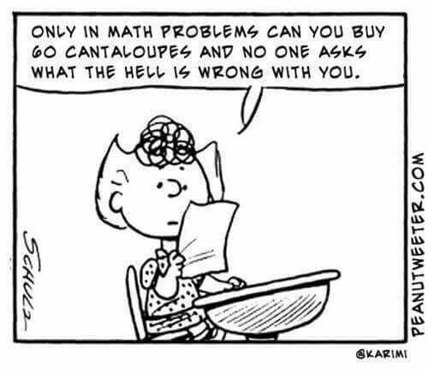

Common myths - He or she will grow out of it!
No, they won’t, it is a lifelong condition, but they will learn to work round it. Parents can help with this by being as supportive as possible and making sure they do things they like and have fun. They will be learning by doing and seeing (without reading or writing) especially if it is done in a fun way.

Indications at secondary level
At secondary level, earlier difficulties may persist as well as new problems arising in coping with the increased demands of the curriculum. They may show many of the following features in

Reading
- Inaccuracies, for example when reading examination questions. | - Difficulty in getting the main idea.
- Difficulties coping with heavier reading demands. | - Reading level lower that the textbooks in that subject area.
- Poor skimming and scanning. | - Poor speed of reading.
- Persistent spelling difficulties.

Writing
- Difficulties in copying from the board. | - Problems with legibility and speed of handwriting.
- Difficulty organising and structuring written work. | - Difficulty with use of punctuation.
- Choosing simple vocabulary that they can use because it is easier to spell. | - Slipping between tenses going from the past to the present.
- Difficulty in spotting errors and proofreading.

Another myth - “Dyslexics are lazy if they were to work harder at it they would read and spell better! “
- The dyslexic brain works differently as proven by brain scans.
- Trust me your child has worked a lot harder in school today than a child who is not Neurodiverse.

Listening and processing
- Problems with notetaking, unable to listen and write at the same time.
- Difficulty in following more than one instruction at a time.
- Difficulty with concentration and attention.
- Difficulty getting to the important points of the information presented.

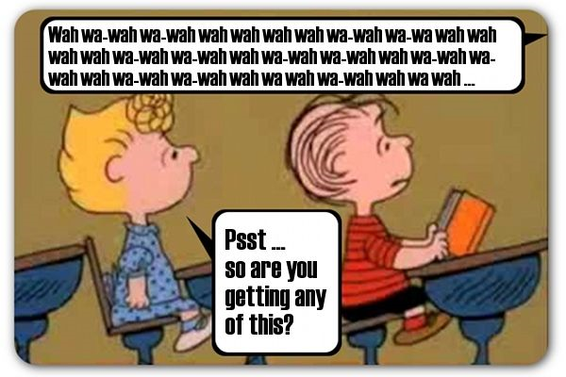

Language .
- Problems with word retrieval.
- Difficulty in acquisition and recall of topic/subject words and their meanings.
- Slow to answer questions, may know the answer can’t always recall the words needed quickly.
- Unable to cope with a fast pace of verbal input, particularly if the sentence structure is complex.
- More easily distracted by environmental noise.

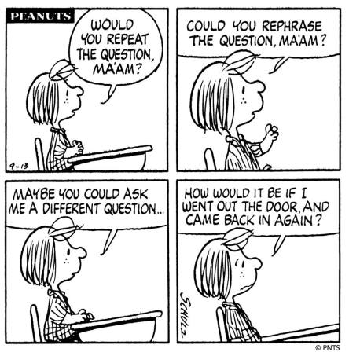

Organisation
- Poor organisational skills, e.g. problems with having the right equipment, planning their work, time keeping and meeting deadlines.
- Problems coping with more homework and lengthier assignments; often unsure of the precise requirements of homework set.

General
- Difficulties with memory.
- More easily tired than peers because of failure to achieve automaticity with many everyday activities.
- More prone to examination stress.
- Difficulty with studying foreign languages.
- Often better at practical subjects where less reading and writing is involved.
- Low self-esteem, leading possibly to behaviour problems and truancy.

What I have learnt
- Dyslexia is a common learning difference (around 10 % of the population).
- Dyslexia has nothing to do with how clever someone is. It’s not a problem with vision: It’s caused by differences in the brain.
- It is not caused by poor teaching
- In about 40 years working with primary children. I have met children who do not have the words or the understanding to tell you what is wrong, so they behave differently from their peers. They may act out to avoid doing those activities they struggle with because they do not fully understand why they struggle. They begin to believe the labels stupid, naughty or that they have behavioural problems. They are none of these things. We as adults have to ask ourselves
"What is the behaviour trying to tell us?"
- Dyslexics need to understand what their dyslexia means and that someone believes in them. One of the most important things, I have discovered when talking with adult dyslexics is those who during their childhood had a significant adult, who believed in them, have better self esteem.

Another Myth - You can’t test/assess for dyslexia until the child is seven/eight.
- Seven/eight is the age when it becomes easier to measure the difference between chronological age and reading and spelling ages as measured in formal assessments.
- The guidance for assessors has changed and they have to work to much stricter guidance so it is harder to get an assessment carried out before this age
- But there are tests/assessments that EP or dyslexic trained assessor can do that will pick up traits of dyslexia before this age.
- There are screenings that can be administered either paper based or on a computer on children under seven.

Screenings
These are a series of assessments that identify areas of concern that are common dyslexic traits.
Most focus on
- Phonological awareness: the ability to identify and manipulate the sounds of language.
- Rapid recall: a measure of Rapid Automatic Naming (RAN). RAN is a strong predictor of literacy development. Those that are slower at naming items are at higher risk for reading/literacy difficulties and dyslexia.
- Working memory: (often Digit span) A measure of working memory's storage capacity.
- Phonological memory is the ability to hold information (numbers, sounds, words) in working or short-term memory so that you can work with them.
- Visual sequential memory: requires a student to remember the order or sequence of numbers, items, pictures, and/or words after viewing them.
- Visual memory: the ability to remember or recall information such as activities, pictures or words that have been viewed in the past.

A screener is not designed to generate a definitive identification of dyslexia, it is meant to provide a fast snapshot of difficulties.

DABBGL uses Dyslexia Quest as it is a quick screener that looks broadly for typical signs of dyslexia. One of our screeners will discuss your concerns about your child. We run the screening and afterwards we discuss the results with further advice on what to do as well as giving some ideas on supporting your child. Our screeners have a good understanding of dyslexia and other neurodiversity as well as personal experience.

The screening provides further information so you can consider whether it would be advisable to either invest in specialist teaching or further investigation with a more specific assessment.
The typical difficulties the screener looks for are often shown by children within the age categories but it will not be as accurate as an assessment designed for specific ages. A screener is not meant to replace an assessment by an educational psychologist (or qualified specialist teacher), such an assessment will take 2-3 hours and typically cost between £500-£2000.

Formal assessments: Specialist teacher (dyslexia trained) or Educational Psychologists?
Both these groups of people need to have professional qualifications and be registered with a professional organization.

A trained assessor (specialist teacher): Must complete a postgraduate (level 7) (a credited course which leads to an assessment practicing certificate (APC). See BDA website.

An Educational Psychologist: In order to practise as an educational psychologist in England, Wales and Northern Ireland have undergone appropriate training and achieved qualifications that are recognised by the Health and Care Professions Council (HCPC) as demonstrating competence and "fitness to practise" as an educational psychologist. Educational psychologists who offer a service to the public are required by law to be registered with the HCPC.

Taken from The British Dyslexia Association “What to Look For in a Dyslexia Assessor”.
“It is important when booking a diagnostic assessment for dyslexia to ensure that the assessment is carried out by a professional who is suitably qualified. For those who are not booking an assessment through an organisation such as the British Dyslexia Association, this is even more important to bear in mind to ensure that your assessment and report are of the appropriate standard.
Below is some guidance for those seeking a diagnostic assessment with a specialist teacher or other professional.

In order to be able to diagnose dyslexia the individual carrying out an assessment should hold the following:
1. An Assessment Practising Certificate (APC) if they are a specialist teacher assessor. This needs to be current as this certificate requires renewal every 3 years.
2. Specialist Teacher Assessors should also hold a level 7 specialist qualification and ideally be a member of a professional body such as the BDA in which case they will hold what is known as AMBDA. Professional membership of such organisations as the BDA, PATOSS or The Dyslexia Guild mean that the assessor is obliged to undertake regular Continuing Professional Development (CPD) and keep up to date.
3. All assessors should also have DBS clearance and be able to provide evidence of this. The individual being assessed may be alone with the assessor during the assessment process so it makes sense to check this.
4. All assessors should also hold Professional Indemnity Insurance
Psychologists: Where an educational or in some cases an occupational psychologist is carrying out the assessment, they must be registered with a professional body such as HCPC, have DBS clearance and also hold professional indemnity insurance.”

Any further questions or advice, please contact us :
Dyslexia association of Bexley, Bromley, Greenwich and Lewisham
http://dyslexiawise.co.uk/
Helpline number 0300 999 1800
Adult helpline number 07762 265 827 Monday-Wednesday 5pm-7pm
Our help liners are able to help with most dyslexia-based enquiries.

General information British Dyslexia Association: https://www.bdadyslexia.org.uk/
Helpful information
(We do not endorse any of the services on this list but we do have close links with the following.)
- Touch-type to read and spell: https://www.readandspell.com/
- Local tutor-led touch typing classes: http://www.trainydays.co.uk/
- Bell house (who are based in Dulwich) offer courses for parents, children and teachers including short information and training videos plus their annual Dyslexia Fair. https://www.bellhouse.co.uk/

Other useful websites or sources of information I have found
- A global charity, led by successful dyslexics. Their purpose is to help the world to understand, vaule and support dyslexia. http://madebydyslexia.org/
- Touch typing online Kaz type https://kaz-type.com/ more suitable for older children and adults.
- Games for the computer, Word shark and number shark https://www.wordshark.co.uk/
- Listening books a long established british charity. To qualify for the service, you must have a disability, illness, learning difficulty or mental health condition that impacts on your ability to read or hold a book. Small subsribition but free if you are unable to pay. The books include text books and study guides. www.listening-books.org.uk
- Tiimo app for structure, time management, icons and encouraging reminders www.tiimoapp.com

Printable guides from the BDA
- Early Help Better Future A Guide to the Early Recognition of Dyslexia by Jean Augur.
- https://cdn.bdadyslexia.org.uk/uploads/documents/Advice/early-help-better-future.pdf?v=1554464143
- Understanding and supporting neurodiversity support strategies for all parents and carers
- https://cdn.bdadyslexia.org.uk/uploads/documents/Advice/Webinar-Training/Support_strategies_for_all_parents_and_carers_250118_copy.pdf?v=1554825979

Useful sites for explaining dyslexia to your children (and others)
The nessy website has some good resources for pupils , parents, teachers and others including explaining dyslexia and ideas for supporting children.
Nessy : https://www.nessy.com/uk/

Mical:- a film of an eight year old boy, who can't even spell his own name, is bullied at school for being unable to read. Based on the inspiring true story of Mike Jones and his mother Pat, 'Mical' is an emotionally charged story of Mike’s dyslexia and how Pat’s persistence and determination changed everything. https://www.youtube.com/watch?v=p-Eycme4NFM

For Primary children
See dyslexia differently https://www.youtube.com/watch?v=11r7CFlK2sc
What’s it like being dyslexic https://www.youtube.com/watch?v=IEpBujdee8M
My dyslexic mind https://www.bbc.co.uk/newsround/20783005
Dyslexia: what is it ? https://www.bbc.co.uk/newsround/20783002

A visual explanation of why children with multiple neurodiverse traits miss out on the support they need from “Do-IT Solutions” Professor Amanda Kirby Founder and CEO

https://www.youtube.com/watch?v=oXbrkQCrzUw&feature=youtu.be

For older children:
Dyslexia awareness: film from “made by dyslexia” https://www.youtube.com/watch?v=DgHDQeZ5QuA
An endearing and encouraging video about a Head and pupil both being dyslexic:
https://www.facebook.com/730742830430712/posts/1642851482553171/?vh=e

The final word
- “Everybody is a genius. But if you judge a fish by its ability to climb a tree, it will live its whole life believing that it is stupid.” Albert Einstein.
- “As a high school student many of my teachers label with me dumb, I could barely read my text book”. Muhammad Ali
- “Imagine a dyslexic from London meeting the Queen of England it’s mind-boggling stuff but that shows how much potential you have.” Maggie Aderin-Pocoke on receiving the MBE.
- “Be yourself. No one can say you’re doing it wrong.” ~Charles M. Schulz

Can you support our charity please? 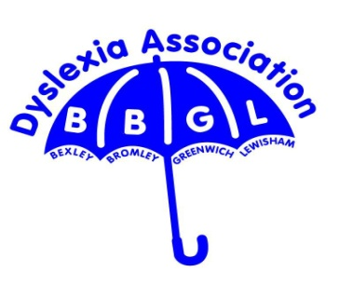

DABBGL http://dyslexiawise.co.uk/
The Dyslexia Association of Bexley Bromley Greenwich and Lewisham gives information to and help for parents, teachers, adults and interested professionals. The separate adult group is open to anyone over 18 from any area within commutable distance of Bromley.
Everyone working for the Dyslexia Association of Bexley Bromley Greenwich and Lewisham does so in a voluntary capacity. We have no paid staff.
There are over 150 members of the Association.

Our Public meetings are held
St Nicholas Church Hall (Village Hall)
Church Lane
Chislehurst
BR7 5PE
The hall is located at The Bull pub end of Church Lane.

What does the Dyslexia Association provide?
- Open Meetings – free entry to everyone, including non-members but donations welcomed.
- Separate Adult Group meetings.
- Special events and conferences.
- Information about national conferences and courses.
- A freely accessible helpline.
- A dyslexia screening service for children and adults.
- Information on special educational needs stages in school.
- Assistance from trained Befrienders.
- Information on Statutory Assessments.
- Training for employers, schools, parents, etc.
- Signposting specialist teaching.
- Signposting Educational Psychology assessments.
- Signposting Adult assessments.
- Three newsletters a year.
- British Dyslexia Association’s Contact magazine three times a year.
- Activities for children

We rely on membership, donations and volunteers for all our activities.
These are some easy ways to help raise funds for us: details on the website.
- Register for free at www.giveasyoulive.com (online fundraising platform) and enter Dyslexia Association of Bexley, Bromley, Greenwich and Lewisham as your chosen charity
- Donating via our JustGiving page - https://www.justgiving.com/dyslexiawise
- Donating via Donr - text DABBGL and the donation amount to 70085 e.g. DABBGL £10 to 70085. The default amount is £5, so texting DABBGL to 70085 will donate £5.
- Bexley Community Lottery - https://www.bexleycommunitylottery.co.uk/support/dyslexia-association
- Amazon Smile

