

**Support Plan:**

[](http://www.google.co.uk/url?sa=i&rct=j&q=&esrc=s&source=imgres&cd=&cad=rja&uact=8&ved=0ahUKEwiQiYqRqcHQAhXCnBoKHW3iDusQjRwIBw&url=http://kingofwallpapers.com/detective.html&psig=AFQjCNGANAjD6oIxU3HFHyIpKnFJpvY-7A&ust=1480074452001671)**Behaviour that challenges**

We like to consider behaviour as a form of communication. Behaviour that challenges often occurs when your child may be trying to communicate that they are unhappy, in pain or even frightened or anxious.   
In order to reduce behaviour that challenges we often start by trying to identify the following:

* What is the cause of the behaviour? Is it to gain something, to gain or maintain interaction with someone, sensory stimulation or to avoid/escape a situation?
* Are there times when the behaviour happens more often? At lunchtime playtime, in the morning, on Wednesdays, after an hour of English lessons etc?
* Are there times when you never see the behaviour? After your child has had sing-a-long, at school, when younger children are present?
* What is your reaction after the behaviour? Does your child enjoy this reaction? Do you take your child out of the activity, stop what you’re doing and play with them, give them a hug, tell them off…

**Clear limits and boundaries, structure and consistency are so important.**Make sure everyone involved with your child is aware of what you are doing so they are able to do the same.

Stay true to your word so what you say is reliable. If you say ‘at 5pm you will have a reward’ - ensure this happens because 10 minutes late can feel like a lifetime for your child.   
Be aware that if you do delay a reward, it may not be fair to punish behaviour that occurs in the interim as it could be a response to having a promise broken.   
For some children, terms such as ‘later’ and ‘in a minute’ have no meaning and can be experienced as forever- try to be specific.

**Environmental changes**

It may not be possible for your child to change, so we may need to adapt the environment to suit the child. For example, if a shopping trip triggers challenging behavior, can you avoid taking them?

**Reinforce appropriate behaviours**

* [](http://www.google.co.uk/url?sa=i&rct=j&q=&esrc=s&source=imgres&cd=&cad=rja&uact=8&ved=0ahUKEwiQ6IX9q8HQAhVB6xQKHbuTD-kQjRwIBw&url=http://www.toms.com/passport&psig=AFQjCNGYTL0p-2MnfQl5BkqTolMXHaaeug&ust=1480075133707405)Aim to praise and encourage your child 5 times for every 1 correction
* What behaviours can you ignore? If it does not put your child or others at risk, is it necessary to respond? Try to redirect your child to do what you would like them to do instead or something that is of interest to them.
* Make sure when you praise you do not instantly take it away or minimise the achievement (e.g: “W*ell done for doing all your homework…I wish you would do it all the time.”)*
* Be really enthusiastic when you give praise to emphasise their achievement.
* Praise effort (e.g: “I could see you tried so hard to….I am so proud of you.

**Tangible reward and incentives**

* At the initial stages make the reward is instant so your child can experience the immediate benefits of doing the desired behaviours
* Do not take rewards away - your child has worked really hard to achieve that reward and it can feel like it is lost so easily.
* You may want to do a fairly big reward at the end of each day (e.g. 30mins on the computer)
* [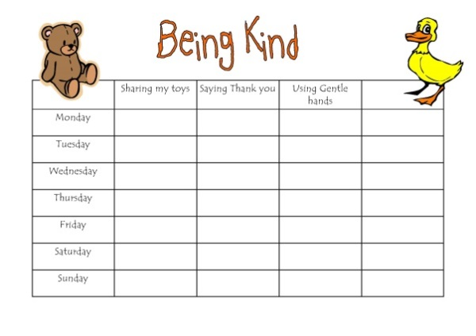](https://www.google.co.uk/url?sa=i&rct=j&q=&esrc=s&source=images&cd=&cad=rja&uact=8&ved=0ahUKEwii9sLIqsHQAhXQSxoKHQyAAgoQjRwIBw&url=https://www.pinterest.com/michi080190/reward-charts/&bvm=bv.139782543,d.ZGg&psig=AFQjCNE0ZLxRqWuzhKJ57LyJ4Dh0OKvPmg&ust=1480074794205743)You may want to do a big reward at the end of the week (e.g. go to the science museum/ park at the weekend).

Make this something your child will look forward to and try their hardest for, but make sure it is achievable.

Telling them to be good every day may not be easy and is not very clear, so for example, as them to use ‘gentle hands’ and they will get a smiley face.   
If they get four smiley faces for three days in the week, you can go to the science museum on Saturday.  
This states clearly the expectations and the reward being aimed for.

Try not to use monetary rewards as it may become expensive for you.

**Special time  
It’s important that you have uninterrupted time together**

As often as possible/ necessary that can be maintained consistently- we usually recommend 20- 30mins minimum

[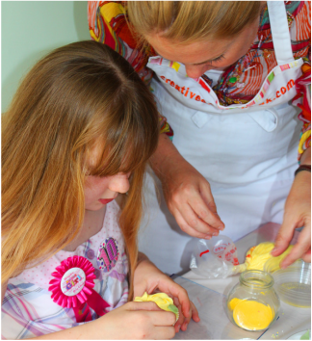](http://www.google.co.uk/url?sa=i&rct=j&q=&esrc=s&source=imgres&cd=&cad=rja&uact=8&ved=0ahUKEwjYge7NrMHQAhXHthQKHTGwAXoQjRwIBw&url=http://www.creativecreations.uk.com/parent--child-workshops.html&psig=AFQjCNHLjTAFj3l4Z8lCAcKVKdAj6D_jEg&ust=1480075384771609)This could be as simple as reading a book, drawing/painting together, playing hide and seek or even playing with your child’s favourite toy alongside each other.

You may decide for this to be child-led (your child decides what you do from a list of options you provide - three options is usually enough) or you can take it in turns to decide during one special time session.

If your child finds it difficult to focus on one task you can do lots of different activities.

[](http://www.google.co.uk/url?sa=i&rct=j&q=&esrc=s&source=imgres&cd=&cad=rja&uact=8&ved=0ahUKEwio_KrWrMHQAhUM7RQKHfWeCCQQjRwIBw&url=http://www.newyorker.com/magazine/2015/01/12/talking-cure&psig=AFQjCNHfNxuIIM3GV5dCNNNu7ij4D-73hA&ust=1480075402544127)**Act as a model for how to problem-solve and have self- control.**

Your child may struggle to think of alternative strategies when problems occur. Support your child to:  
STOP  
BREATHE  
THINK  
 ACT

**What if they behaviour is dangerous to your child or others?**

Sometimes, your immediate reaction may be to shout at your child but this is ineffective!   
Try to de-escalate the situation and enforce clear and consistent consequences (i.e. time out, removing privileges such as early bedtime or no computer games) for the behaviour:

* **Focus on safety-** Remove children and others from the area; remove any objects that can be unsafe if thrown.
* **Maintain calmness and speak in a soft, slow voice-** We often mirror the voice and tone of those we speak to, so this will help your children lower their voice and help them to calm down.
* **Model emotional regulation-** Don’t appear angry or raise your voice. Your child will feed off of your anger because he or she is looking for an emotional response from you.
* **Redirect your child with a new activity-** Try to distract your child with a pleasurable activity or toy.
* **Don’t bargain or bribe your child during an outburst-** Children cannot use logic or reasoning skills during an outburst.
* **Communicate one thought or idea at a time-** Children are not using rational thinking skills during an outburst and you do not want to overwhelm your child with speaking in long sentences.
* **Don’t discipline-** By trying to discuss the tantrum or give consequences you will only escalate your child’s tantrum.
* **Try relaxation techniques-** Encourage your child to count to 10 before speaking or take deep breaths.
* **Body language** – Don’t stand in front of your child. Have an open posture and a calm but firm voice.
* **Acknowledge your child’s feelings** – Tell them: “I can see you are upset.”
* **Tell your child what you want them to do, not what you don’t want** – e.g. “sit down” rather than “stop shouting”.

**Remember to be FIRM, look after yourself and always ask for help**

Sometimes it gets harder before it gets easier. Do not give up!

**Web based self-help tools and advice:**

In conjunction with Young People we have developed a web based programme called Headscape. This has information, tips and advice and helpful things to download; here’s how to access it:

[**http://headscapebexley.co.uk**](http://headscapebexley.co.uk)

Other websites that you might find helpful are:

<http://familylives.org.uk> Previously parent line – online forums and parent courses

[www.onespace.org.uk](http://www.onespace.org.uk) Website for single parents – online forum, courses and information

[www.psg.org.uk](http://www.psg.org.uk) Parent Support Group - helpline and advice

[www.youngminds.org.uk](http://www.youngminds.org.uk) YoungMinds’ Parents’ information service

[www.dad.info](http://www.dad.info) Website has articles podcasts etc

[www.childline.org.uk](http://www.childline.org.uk) Tel: 0800 1111

[www.mencap.org.uk/advice-and-support/displaying-challenging-behaviour](https://www.mencap.org.uk/advice-and-support/displaying-challenging-behaviour)

[www.challengingbehaviour.org.uk/](http://www.challengingbehaviour.org.uk/)